RCMS Annual Food Drive
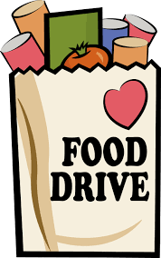
November 16th – December 18th
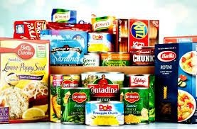

Non-perishable/non-expired items can be dropped off in tubs at Door 1. Items donated will be shared with three food banks on behalf of RCMS students. Thank you for your support!

Suggested Items:

- Canned/bagged beans (baked, black, pinto, red, baked, green, lentil, fava beans)
- Gravy (canned or packets), canned pumpkin, canned cranberry sauce, stuffing mix
- Rice, ramen noodles, pasta, jarred pasta sauce, canned/packets of tuna, mac n’ cheese
- Instant mashed potatoes
- Canned tomato sauce, canned fruit/vegetables
- Baking mixes, flour, sugar, brown sugar
- Jell-O/pudding mix, snack items
- Spices, cooking oil, broth
- Oatmeal, cereal, pancake/waffle mix
- Peanut butter, jelly

Please contact Courtney Krsmanovic, School Social Worker
OR Solangie McPherson, Spanish-speaking Parent Liaison if you have questions!

