These directions work on a Dell computer. If your computer is different from that, you might need to modify these a bit.

Making sure your microphone is working:

- Go into your control panel and click “sound”. An easy way to do this is to go to the search bar in the bottom left of your screen and type “sound”
. 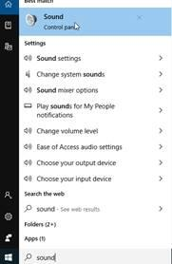
- This screen will open:
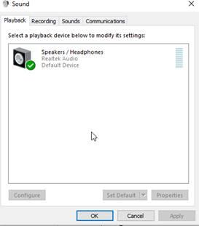
- Click on the second tab which says “recording” and double click on microphone array

- 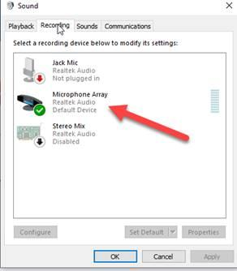

Now click on the third tab which says “levels”
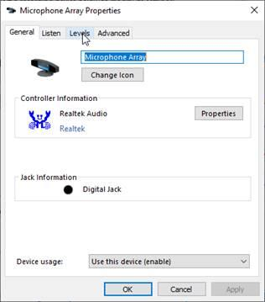
You will likely see that your microphone is muted on this screen. You can fix it, hit apply or ok and it should work!
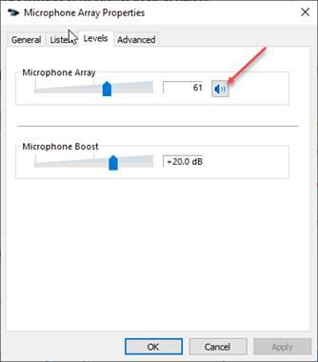

Making Sure your sound is working:

- Go into your control panel and click “sound”. An easy way to do this is to go to the search bar in the bottom left of your screen and type “sound”
.

- Find your speakers listed

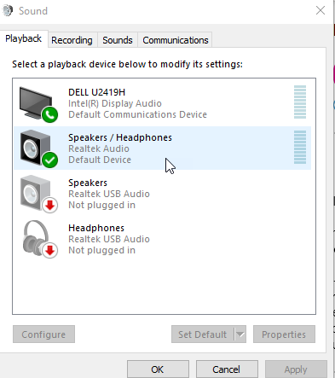

- Click on Properties and then go to levels. Make sure your volume is not muted.
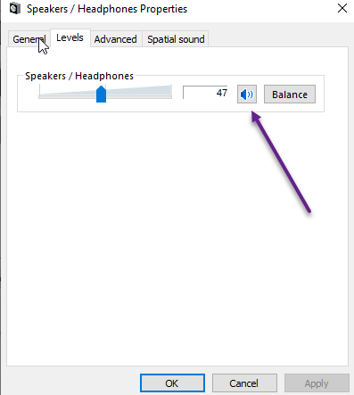
Click “apply” or “save” if you make a change.

